1. This will help you know as a developer what you need to know about networking to troubleshoot issues that you run into.

2.   
  
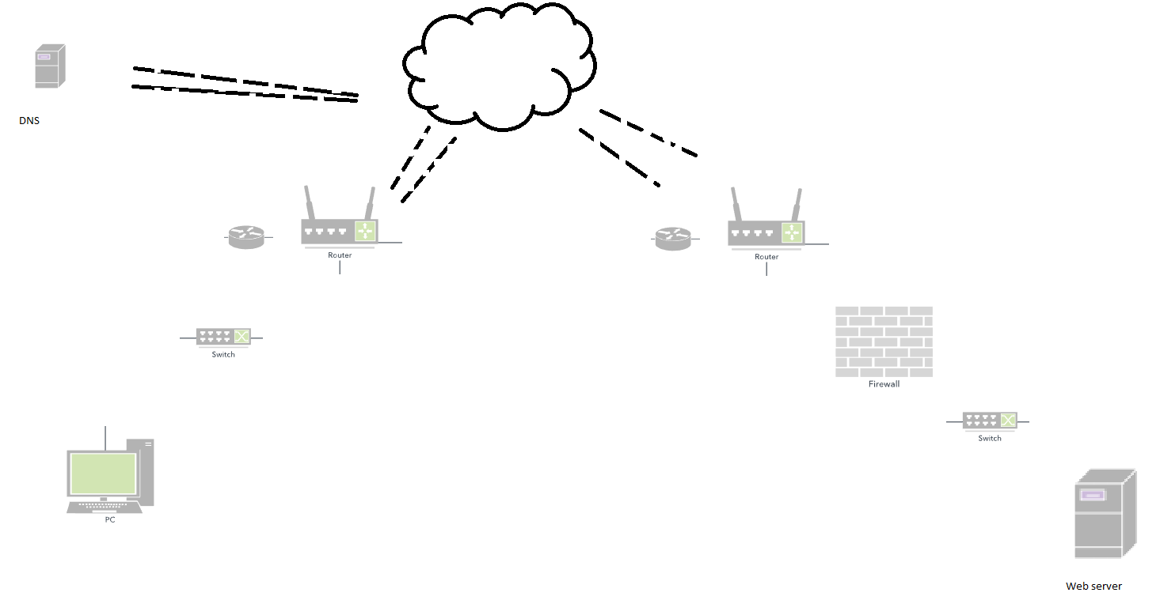

3.

3.1 On the left we have a client trying to reach the webserver on the bottom right.

The first thing the computer needs to do to reach the web server is …

* Convert the url into ip address. It does this with a service called domain naming system / DNS
* So client reaches out to its configured DNS servers and asks the ip of pluralsight.com
* The DNS servers go out find the ip address and returns it to the client.
* As the client knows the ip address – it goes out of its switch through its router out in to the internet, eventually reaching the data center that the web server is located at.
* Its going to pass through firewall and switches and reach the web server.
* As the request reaches that web server – it enters the networking stack of the operating system..it traverses through a host based firewall, then the request reaches the actual webserver.
* When the request is served the process is reversed and data is displayed in the client machine.  
  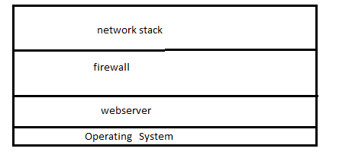

4. NETWORK CONFIGURATION OF A NODE ON A NETWORK.

4.1

Anatomy of an ip address.  
  
**IPv4 Address. . . . . . . . . . . : 10.170.163.96(Preferred)**

**Subnet Mask . . . . . . . . . . . : 255.255.254.0**

**Default Gateway . . . . . . . . . : 10.170.162.1**

**DNS Servers . . . . . . . . . . . : 10.140.46.66**

**10.140.46.99**

**10.140.70.66**

**DHCP Server . . . . . . . . . . . : 10.140.46.66**

**DHCPv6 IAID . . . . . . . . . . . : 233319146**

**DHCPv6 Client DUID. . . . . . . . : 00-01-00-01-23-74-F3-A8-28-D2-44-7F-2A-8A**

4.2

If we look at the network configuration of a node on a network.

ip address : which is made up of 4 octets. [ 10,170,163,96 ]

Subnet mask : subnet **mask** defines which part of the ip address is the subnet, and which part is that specific node on  
 that network.[routing module]

: just remember that if an ip address you want to reach is not part of your subnet it has to go through  
 default gateway.

DNS Servers : which will turn names into ip address.

4.3

ipconfig – will show you basic network information.